MGMT 4650

Financial/Ratio Analysis Quiz

Name________________________________________ Major____________________

Write down or mark your answers clearly. Justify your answers by providing supporting information (for instance, calculated ratios) if the question requires it. Use the reverse sides of pages for any other calculations you need to perform.

Make sure that you have filled in all the identification information asked for above
Note: there are a total of 11 questions to answer. GOOD LUCK!

1. Fill in the blanks and give reasons: (10 points)

 | Company A | Company B
ROE | 2% | 8%
Profit Margin % | 7% | 4%
TAT | 1.7 | 3.0
ROA | 11% | 8.7%
Generic Strategy

How different are the two firms’ financials? How are they related to their strategies?

_________________________________________________________________________________________________

_________________________________________________________________________________________________

__________

Use this information to answer the following questions 2 to and 6.

 | New Tech Company |  |  |  | Industry Average Ratios
Income Statement | 2007 | 2008 | 2009 |  |  | 2007 | 2008 | 2009
Sales | 100 | 110 | 120 |  | CR  (Current Ratio) | 1.5 | 1.5 | 1
Cost of goods sold | 50 | 51 | 52 |  | DR (Debt Ratio) | 50% | 50% | 50%
Depreciation | 20 | 20 | 20 |  | TAT | 2 | 2.2 | 2.5
General, sales & admin expenses | 70 | 65 | 60 |  | PM | 4% | 5% | 6%
Taxes | 10 | 10 | 10 |  | Sales Growth | 3% | 2.50% | 3%
Net Income | -50 | -36 | -22 |  | Profit Growth | 5% | 25% | 20%
Balance Sheet | 2007 | 2008 | 2009
Current Assets | 40 | 45 | 40
Property, plant & equipment | 60 | 55 | 60
Total Assets | 100 | 100 | 100
Current Liabilities | 40 | 40 | 35
Long-Term Liabilities | 10 | 10 | 15
Equity | 50 | 50 | 50
Total Liabilities & Equity | 100 | 100 | 100

2. Which of the following items do not characterize New Tech Company ? EXPLAIN with
the appropriate ratios/measures. (10)
A. positive sale growth
B. high debt
C. increasing profit margin
D. all the above characterize New Tech Company

3. Which expense item shows the greatest growth in percentage terms at New Tech? EXPLAIN with numerical calculations. (5)
- Costs of goods sold
- Depreciation
- General, sales and admin.
- Taxes

4. Using the figures above, in what year would you anticipate New Tech will REPORT a profit? EXPLAIN with numerical calculations. (5)
- 2010
- 2011
- 2012
- 2013

5. The change in ROA for New Tech over the period is due to

A. PM
B. TAT
C. both
D. neither.

Explain using the appropriate ratio(s). (5)

6. The trend for New Tech’s asset turnover is: EXPLAIN! (5)
- Increasing
- Decreasing
- Staying the same
- Can’t tell

7. The trend for New Tech’s current ratio is: EXPLAIN! (5)
- Increasing
- Decreasing
- There is no trend
- Can’t tell

__________

The information below is excerpted from the financial statements of two companies. Use this information to answer questions 8-9
(in $ million) | Company A | Company B
Net revenues | 31296 | 107958
Net income | 1288 | 3426
Total current assets | 29564.5 | 18672.5
Total assets
Total current liabilities | 15370 | 12708.5
Total liabilities | 32030 | 24671
Total stockholders’ equity | 5403.5 | 17823

Footnote: Approximately 98% of Company A’s account receivables are from unpaid balances carried by customers using the store credit card.

8. Which company is less liquid (i.e., more risky in the short-term)? Justify using appropriate ratio(s). (10 points)

_________________________________________________________________________________________________

_________________________________________________________________________________________________

_________________________________________________________________________________________________

9. Which company is more leveraged? Justify using appropriate ratio(s). (10 points)

_________________________________________________________________________________________________

_________________________________________________________________________________________________

_________________________________________________________________________________________________

Use the information below to answer questions 10-11

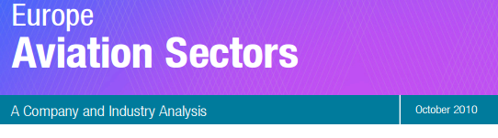
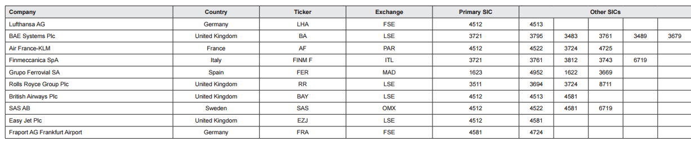

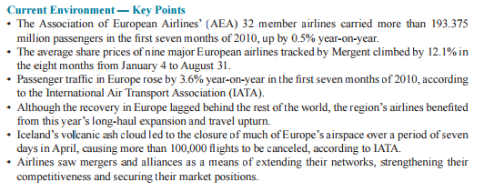

Table -1 % growth in revenues from 2008 to 2009
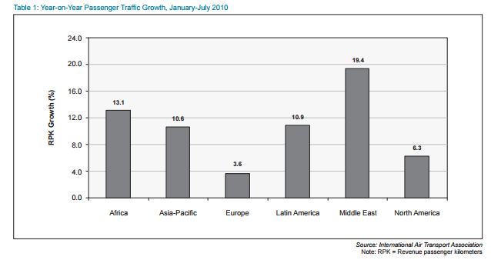

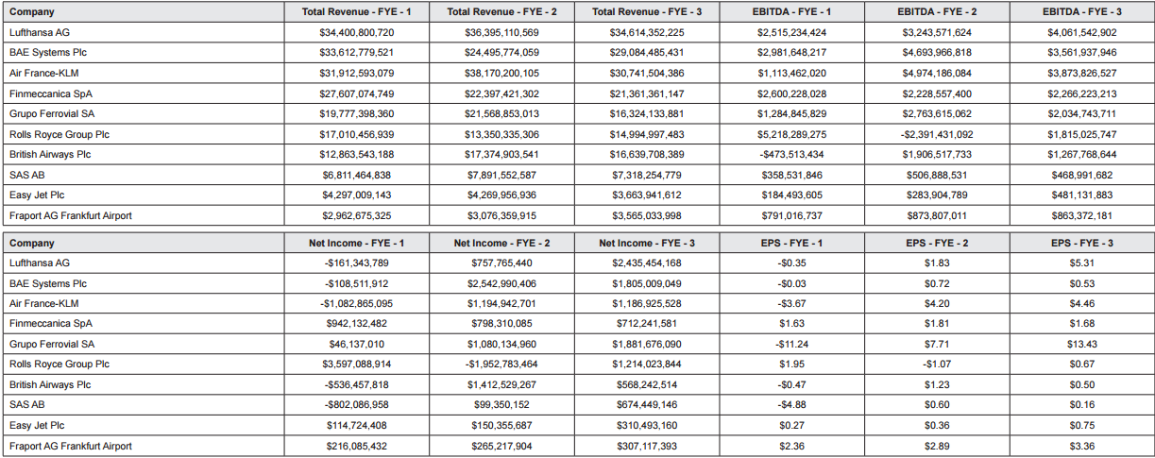
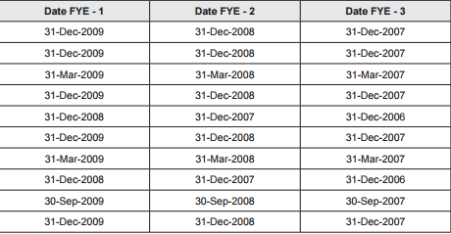

10. Calculate and show % change in revenues for Airline carriers (with primary SIC code 4512) for the year 2009 ONLY (from 2008 to 2009).

Compare and benchmark the growth rate using the industry growth in Table-1 above.

Which airline carrier is better in terms being able to increase their revenues in the year 2009? Which company is the worst? Interpret your analysis by using the information given in the “Key Points-Current Environment” table as well. (20 points)

11. For the year-end 2008 (from 2007 to 2008), which airline carrier (with primary SIC code 4512) was able to increase their profit per each $1 worth of revenues they have generated over that year? Name and create the type of the statement (s) you need to use for such analysis? (15 points)

